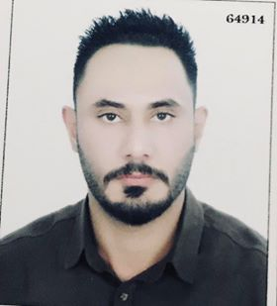**Name:** Ali Hussein Zwayyer

**D.O.B:** 07/May/1989

**P.O.B:** Baghdad-Iraq

**Address:** Baghdad-Iraq

**Phone No:** +9647804042377

**Email:** ali_bash24@yahoo.com

"Well prepared to apply my academic experience to further develop and improve my skills while being a valuable asset to my employer"

**Education and Academic Qualification:**

* B.A in English language / University Of Baghdad
* Member of Iraqi Translators’ Association

**Work Experiences:**

* 2013-2015 Assistant Manager at Hanwha South Korean Company for Engineering and Construction ,Logistic Department / Material Management Team,
* 2015- 2019 VIS American Company for Translation Services as a Linguists Manager.

**Skills:**

* Qualified In Microsoft Office Application, Excel, Word and PowerPoint.
* Qualified to in SPSS Program
* Work under pressure and deal with information in confidential manner
* Fast learner and quick to grasp new ideas and concepts

**Languages:**

* Arabic (Mother Tongue)
* English Read, write and speak

**Certificate & Recommendation:**

* Certificate from Hanwha Korean Company of engineering and construction
* Certificate in Office Programs issued by the Ministry of Labor and Social Affairs.
* Certificate in English Language (Advanced Level) issued by the Ministry of Labor and Social Affairs.
* Certificate in SPSS program issued by Ministry of Youth and Sport
* A letter of recommendation from my formal manager at Hanwha E & C.
* A letter of recommendation from my formal manager at VIS.